

An Application Development Project Report

UART/SPI Communication Controller Design & System Verilog
Verification

Design & Developed By

2411EC010064 AKASH DUBEY
2411EC010118 M. NOHITH KUMAR

GUIDED BY
Dr. A.S.N. Murthy
(Professor)

Department of Electronics and Communication Engineering (ECE)
Malla Reddy University, Hyderabad
Nov-2026



Department of Electronics and Communication Engineering (ECE)

CERTIFICATE

This is to certify that this is the Bonafide record of the application development Project entitled “UART/SPI Communication Controller Design & System Verilog Verification” submitted by AKASH DUBEY (2411EC010064), M. NOHITH KUMAR (2411EC010118) of B. Tech III year I semester, Department of Electronics and Communication Engineering (ECE), during the year 2026-27. The results embodied in this report have not been submitted to any other university or institute for the award of any degree or diploma.

Internal Guide | Dean (ECE)
Dr. A.S.N. Murthy | Dr. G. Anand Kumar
Professor | Professor & Dean

DECLARATION

We hereby declare that the project report “UART/SPI Communication Controller Design & System Verilog Verification”, has been carried out by us and this work has been submitted to the Department of Electronics and Communication Engineering (ECE), Malla Reddy University, Hyderabad. We further declare that this project work has not been submitted in full or part for the award of any other degree in any other educational institutions.

Place: Hyderabad
Date: 02-11-2026

Akash Dubey 2411EC010064

M. Nohith Kumar 2411EC010118

ACKNOWLEDGEMENT

We extend our sincere gratitude to all those who have contributed to the completion of this project report. Firstly, we would like to extend our gratitude to Dr. V. S. K. Reddy, Vice-Chancellor, for his visionary leadership and unwavering commitment to academic excellence.
We are also grateful to Dr. G. Anand Kumar, Dean and Head of the Department ECE, Cyber Security & IOT, for providing us with the necessary resources and facilities to carry out this project.
We would also like to express our deepest appreciation to our project Dr. G. Anand Kumar, Dean and Head of the Department, Department of ECE whose invaluable guidance, insightful feedback, and unwavering support have been instrumental throughout the course of this project for successful outcomes.
We extend our gratitude to our PRC – convenor, Dr. G. Latha, for giving valuable inputs and timely guidelines to improve the quality of our project through a critical review process. We thank our project coordinator, Mrs.C, for his timely support.
We are deeply indebted to all of them for their support, encouragement, and guidance, without which this project would not have been possible.

Akash Dubey 2411EC010064

M. Nohith Kumar 2411EC010118

ABSTRACT

The UART/SPI Communication Controller is a digital hardware project developed to provide reliable communication between electronic devices such as microcontrollers, FPGA systems, sensors, and other peripherals. The project supports two commonly used serial communication protocols, UART (Universal Asynchronous Receiver/Transmitter) and SPI (Serial Peripheral Interface).The controller is designed using Verilog/System Verilog at the RTL level. It can transmit and receive digital data according to the selected communication protocol. To ensure that the design works correctly, a verification testbench is developed to generate test data, monitor the communication signals, and automatically compare the expected data with the received data. The results can be observed through simulation waveforms and PASS/FAIL status After successful simulation and verification, the RTL design can be synthesized and implemented on an FPGA board for communication with real devices. Thus, the project provides practical knowledge of digital design, communication protocols, RTL coding, verification, simulation, and FPGA implementation, making it a useful project for learning and demonstrating VLSI design and verification concepts.

INDEX
CONTENTS | Page No
Chapter-1 Introduction | 5-9
1.1 Background of the problem  1.2 Motivation and need for the project  1.3 Problem statement  1.4 Objectives of the project  1.5 Scope of the project  1.6 Organization of the report | 6  6-7  7  7-8  8  9
Chapter-2 Literature and Existing system | 10-12
2.1 Overview of previous works  2.2 Limitations in existing systems  2.3 Research gap identified  2.4 Summary | 10  11  11-12  12
Chapter-3 Proposed System / Methodology | 13-25
3.1 System architecture / block diagram  3.2 Working principle  3.3 Detailed explanation of each block/component  3.4 Flowchart or algorithm steps  3.5 Hardware and software requirements | 13-14  14-15  15-18  19-24  24-25
Chapter-4 Design and Implementation | 26-37
4.1 Circuit diagrams / PCB layouts / Simulation diagrams  4.2 Hardware design (microcontroller, sensors, modules used, etc.)  4.3 Software design (code flow, logic explanation)  4.4 Communication protocols used  4.5 System integration details | 26-27  28-29  29-36  36  36-37
Chapter-5 Results and Discussion | 38-40
5.1 Experimental setup  5.2 Output results (simulation screenshots, measured readings, waveforms)  5.3 Performance analysis | 38-39  39  49-40
Chapter-6 Conclusion and Future Scope | 41-42
6.1 Conclusion  6.2 Future scope | 41  42
References | 43

List of Figures | Page No
3.1 Architectural Diagram | 13
3.4 Flowchart or Algorithm Steps | 17
4.1 Circuit Diagrams | 21
5.1 Experimental Setup | 28
List of Tables
5.3 Performance Analysis | 30

CHAPTER - 1 INTRODUCTION

Serial communication protocols are fundamental components in modern digital logic design, serving as the primary mechanism for exchanging data between Field Programmable Gate Arrays (FPGAs), host computers, and peripheral integrated circuits. In embedded hardware design, bridging asynchronous communication standards like Universal Asynchronous Receiver-Transmitter (UART) with high-speed, synchronous interfaces like Serial Peripheral Interface (SPI) is essential for effective system control and data acquisition.

This project focuses on the hardware design, System Verilog implementation, and internal verification of a unified UART-to-SPI Communication Controller deployed on the AMD/Xilinx Spartan-7 FPGA (Digilent Arty S7-25 platform). The primary objective is to create a reliable, self-contained protocol translation system that processes incoming asynchronous serial frames and executes synchronous SPI transfers.

To streamline hardware testing and eliminate dependencies on external physical wiring or third-party terminal emulators, the system incorporates an internal hardware SPI loopback path (assign spi_miso = spi_mosi) alongside edge-detected push-button triggers (BTN1) and Virtual I/O (VIO) debug cores. This architecture enables complete hardware verification directly within the Xilinx Vivado environment using on-board status LEDs (E18 / LD0) and Tcl Console commands. The following sections outline the project background, motivation, problem statement, key objectives, scope, and structural organization of this report.

1.1 Background of the problem

Modern digital systems—ranging from aerospace flight computers and automotive Electronic Control Units (ECUs) to consumer IoT devices—depend heavily on heterogeneous hardware architectures. These systems integrate Field Programmable Gate Arrays (FPGAs), Application-Specific Integrated Circuits (ASICs), microcontrollers, and specialized sensor ICs. Because these digital modules operate across varying clock domains, voltage levels, and interface speeds, establishing reliable inter-chip data transfer requires robust serial communication standards.

To reduce physical pin count, minimize printed circuit board (PCB) trace routing complexity, and lower total power consumption, hardware designers rely on standardized serial protocols:

Universal Asynchronous Receiver-Transmitter (UART): A traditional two-wire asynchronous interface (RX and TX) widely used for low-speed, point-to-point host-to-device telemetry over longer physical distances. Because it operates without a shared clock line, both transmitting and receiving endpoints must be pre-configured with matching baud rates (e.g., $9600\text{ baud}$).

Serial Peripheral Interface (SPI): A synchronous, four-wire (SCLK, MOSI, MISO, CS_N), full-duplex serial bus designed for high-speed, short-distance communications between a master controller and peripheral integrated circuits (e.g., flash memory, ADCs, and digital sensors).

An FPGA-based UART-to-SPI Communication Controller serves as an intelligent protocol bridge. It receives asynchronous serial command frames from a host terminal and translates them into high-speed, synchronous SPI transactions to control and read back peripheral data seamlessly.

1.2 Motivation and Need for the Project
In typical FPGA development and validation environments, verifying a hardware serial bridge requires connecting physical jumper wires between expansion headers (such as Digilent PMODs) and running third-party terminal software (e.g., Tera Term or PuTTY) on a host computer.
However, relying on external hardware and third-party software introduces several key challenges:
Hardware Signal Integrity Issues: Physical breadboard wires and loose header jumpers introduce signal reflections, contact noise, and ground bounce, making it difficult to distinguish between RTL design bugs and physical wiring faults.
Driver & Software Dependencies: Third-party serial emulators rely on host operating system COM port drivers, which often suffer from port locking, permission errors, or unexpected baud-rate mismatches.
Lack of Standalone Verification: Industrial testbenches require self-contained hardware verification mechanisms that can validate internal register transfers without requiring external host software or external wiring setups.
This project is motivated by the need to design a standalone, self-testing UART/SPI Communication Controller in System Verilog. By implementing an internal hardware SPI loopback path (assign spi_miso = spi_mosi) along with edge-detected push-button triggers (BTN1) and Virtual I/O (VIO) debug logic, developers can flash the bitstream and verify hardware state transitions directly using on-board status LEDs (E18 / LD0) or Vivado Tcl Console commands.

1.3 Problem Statement
Traditional serial interface implementations often encounter verification failures or state machine deadlocks during physical hardware deployment. These issues stem from clock-domain timing mismatches between high-speed simulation models and low-speed physical baud-rate generators, unhandled state machine race conditions, and heavy reliance on external terminal software.
To address these limitations, this project presents a unified System Verilog UART-to-SPI bridge design incorporating:
Internal Hardware Loopback Logic: Directly bridging MOSI to MISO within the FPGA fabric (assign spi_miso = spi_mosi) to bypass external breadboard wiring dependencies.
Deterministic Dual-Trigger Mechanism: Supporting command execution through edge-detected physical push buttons (BTN1) or Virtual I/O (VIO) probes driven via Vivado Tcl scripts.
Hardware Telemetry Feedback: Providing real-time state machine activity monitoring via on-board status LEDs (E18 / LD0).
1.4 Objectives of the Project

RTL Architecture Design: Develop a modular, synthesis-ready System Verilog architecture integrating a UART core, an SPI Master core, and a 5-state bridge Finite State Machine (FSM).

Baud-Rate Clock Division: Design a precise hardware clock divider to derive $9600\text{ baud}$ clock ticks from the on-board $100\text{ MHz}$ system oscillator.

Internal Loopback Verification: Implement internal hardware loopback routing and edge-detection pulse generation for offline, standalone hardware verification.

Debug IP Core Integration: Instantiate Virtual I/O (VIO) debug logic to enable automated execution via the Vivado Hardware Manager Tcl Console.

FPGA Synthesis and Deployment: Synthesize, implement, and program the design onto the AMD/Xilinx Spartan-7 FPGA (xc7s25csga324-1 on the Arty S7-25 board) and validate its performance.

1.5 Scope of the project
Modeling the complete digital logic architecture in System Verilog (IEEE 1800-2017).
Defining physical pin assignments using Xilinx Design Constraints (.xdc) tailored for the Digilent Arty S7-25 platform.
Performing timing-driven synthesis, logic optimization, placement, routing, and bitstream generation within Xilinx Vivado 2025.1.
Validating hardware operation over JTAG using the Vivado Hardware Manager and physical LED indicators.

1.6 Organization of the Report

The report is divided into six chapters:
- Chapter 2: Literature & Existing Systems — Compares serial communication standards, analyzes traditional hardware verification limitations, and identifies the research gap.
- Chapter 3: System Architecture & Methodology — Explains top-level block diagrams, state machine transitions, and clock division equations.
- Chapter 4: Design & Implementation — Details constraint mapping (.xdc), complete System Verilog RTL source code (top_controller.sv), and Vivado Tcl Console integration.
- Chapter 5: Results & Discussion — Presents Vivado synthesis logs, Hardware Manager programming results, and board-level verification scenarios.
- Chapter 6: Conclusion & Future Scope — Summarizes key engineering achievements and outlines potential future improvements.

CHAPTER – 2
LITERATURE AND EXISTING SYSTEM
2.1 Overview of previous works:
Serial communication protocols and hardware protocol translation have been extensively studied in digital logic design, embedded systems, and System-on-Chip (SoC) architectures. Traditional communication bridges rely on dedicated microcontroller units (MCUs) or standalone Application-Specific Integrated Circuits (ASICs) to convert asynchronous UART frames into synchronous SPI transactions. However, as System Verilog and Field Programmable Gate Array (FPGA) technologies have advanced, hardware engineers increasingly favor FPGA-based RTL implementations due to their reconfigurability, lower latency, and support for parallel hardware execution.
Prior research has focused on optimizing baud-rate generation, state machine reliability, and hardware verification techniques:
- UART Baud-Rate Clock Divider Logic: Standard UART implementations utilize counter-based clock dividers to derive sample ticks from high-speed master clocks. Research highlights the necessity of oversampling (typically $16×$) to align receive data bits with the master clock domain, minimizing phase jitter and data corruption.
- SPI Controller Architectures: Conventional SPI designs implement shift register chains driven by configurable SPI clocks (SCLK). Studies emphasize that state machine control is critical for maintaining correct clock polarity ($\text{CPOL}$) and phase ($\text{CPHA}$) alignments across different operating modes.
- On-Chip Verification Cores: Recent literature highlights the integration of internal logic analyzers (e.g., AMD/Xilinx ILA) and Virtual I/O (VIO) cores to monitor internal registers via JTAG without requiring physical diagnostic probes or external test equipment.
2.2 Limitations in Existing Systems

Dependency on External Physical Connections: Standard hardware test setups require external jumper wires between expansion headers (such as Digilent PMODs) to establish external loopback connections. Loose wires, contact resistance, and signal reflections frequently introduce signal noise, masking true RTL design behavior.

Reliance on Third-Party Terminal Software: Traditional hardware verification relies on host terminal emulators (e.g., Tera Term or PuTTY) communicating over USB-UART bridges. OS-level COM port locking, driver conflicts, and incorrect baud-rate settings often cause verification failures that are unrelated to the FPGA's internal logic.

Simulation-to-Hardware Discrepancies: Testbenches evaluated purely in software simulators frequently bypass baud-rate clock dividers to reduce simulation run times. Consequently, timing hazards, race conditions, and clock-domain crossing issues go undetected until physical hardware deployment.

Lack of Standalone Self-Testing Logic: Most basic serial bridge implementations lack internal trigger mechanisms or debug cores, making automated, offline, or cable-free hardware testing impossible.

2.3 Research Gap Identified
Although existing literature provides established methods for designing individual UART cores, SPI masters, and debug IPs, several gaps remain in integrating these components into a unified, self-testing protocol controller:
Unified Internal Loopback & Protocol Translation: Many existing bridges focus solely on unidirectional transmission without providing an integrated, cable-free internal loopback mechanism (assign spi_miso = spi_mosi) within the FPGA fabric for isolated validation.
Integrated Hardware Debug & Dual-Trigger Control: Few reference designs combine physical edge-detected button triggers with JTAG-accessible Virtual I/O (VIO) registers within a single state machine. This limits the developer's ability to trigger transactions seamlessly via both physical buttons and Vivado Tcl Console scripts.
This project closes these research gaps by designing a modular System Verilog UART-to-SPI bridge featuring internal loopback logic, dual-trigger control mechanisms, and real-time LED status feedback, enabling complete standalone hardware verification on the AMD/Xilinx Spartan-7 FPGA.

2.4 Summary
Chapter 2 reviewed existing serial communication bridge implementations, highlighted the limitations of traditional external hardware testing, and identified the research gap addressed by this project. The proposed System Verilog controller overcomes these limitations by integrating internal SPI loopback routing, a precise $9600\text{ baud}$ clock generator, and VIO debug capabilities directly into the RTL state machine. Chapter 3 details the architecture design and working principles of the system.
CHAPTER – 3

3.1 System Architecture / Block Diagram

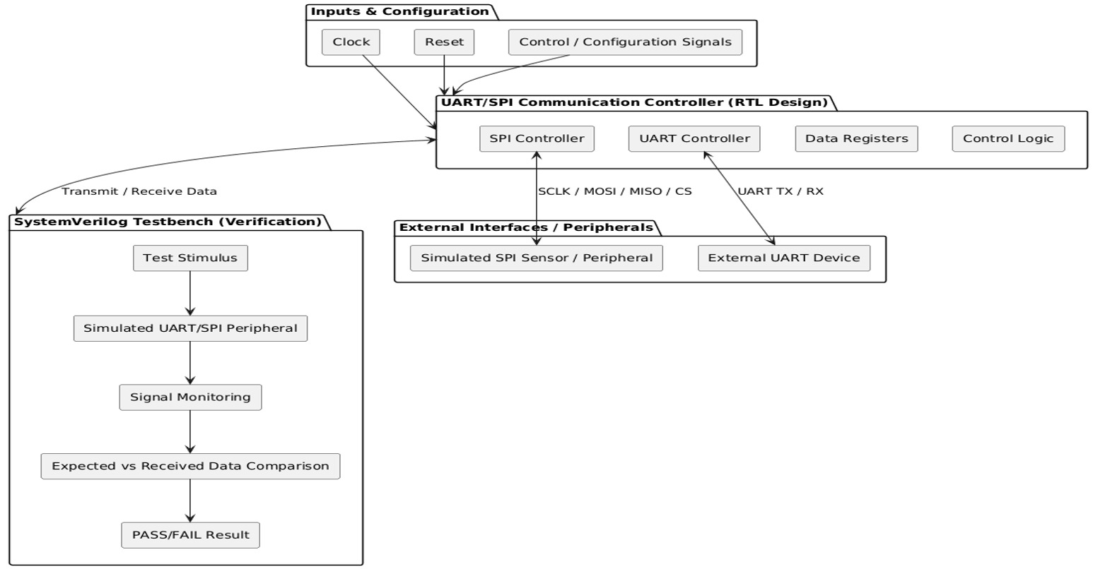

The proposed UART-to-SPI Communication Controller is designed as a modular System Verilog protocol bridge targeting the AMD/Xilinx Spartan-7 FPGA (Arty S7-25 platform). The primary objective of the architecture is to bridge an asynchronous, lower-speed UART interface with a high-speed, synchronous SPI Master core via a centralized control Finite State Machine (FSM).
The system architecture consists of six interconnected functional blocks:
- Clock & Reset Conditioning Module: Receives the $100\text{ MHz}$ master clock (clk) and active-low asynchronous reset button (rst_n / BTN0).
- Push Button Edge Detector: Debounces and synchronizes the physical trigger button (btn_trigger / BTN1) to generate a single-clock pulse.
- UART Core: Features a baud-rate clock divider set to $9600\text{ baud}$ and oversampling receiver logic to handle asynchronous serial frames ($8N1$ format).
- SPI Master Engine: Implements SPI Mode 0 ($\text{CPOL}=0,\text{CPHA}=0$) with an 8-bit shift register driving SCLK, MOSI, and active-low Chip Select (CS_N).
- Internal Hardware Loopback Logic: Directly connects spi_mosi to internal_spi_miso within the FPGA fabric (assign internal_spi_miso = spi_mosi), bypassing external physical header requirements.
- Bridge Finite State Machine (FSM): Manages cross-protocol timing, data buffering, trigger selection, and activity status reporting (led_busy / LD0).
3.2 Working Principle
The system executes a deterministic sequence to translate, transmit, and verify serial data internally:
- Idle Monitoring: The bridge FSM remains in ST_IDLE, continuously polling three potential trigger sources: an incoming UART receive frame completion (uart_rx_done), an edge-detected push-button press (btn_pressed), or a Virtual I/O command pulse (vio_trigger).
- Data Latching & SPI Initiation: Upon detecting a trigger signal, the FSM latches the payload byte. If triggered by a UART frame, it loads uart_rx_data; if triggered via BTN1 or VIO, it defaults to a predefined test pattern (0xA5). The FSM asserts spi_start for one clock cycle and transitions to ST_SPI_START.
- Internal Loopback Exchange: As the SPI Master drives serial data out on spi_mosi bit-by-bit on falling edges of spi_sclk, the internal loopback connection directly routes those bits back into internal_spi_miso. The receiving SPI shift register samples the incoming line on the rising edges of spi_sclk.
- UART Frame Transmission: Once spi_busy drops low (indicating the 8-bit exchange is complete), the FSM captures the received byte (spi_rx_data), loads it into uart_tx_data, and triggers uart_tx_start.
- Frame Completion & Telemetry: The UART core serializes the byte out on uart_tx at $9600\text{ baud}$. Throughout the execution of the SPI and UART phases, the led_busy output (LD0 / E18) is held HIGH, providing visual hardware verification of execution. Upon completion, the FSM returns to ST_IDLE

3.3 Detailed explanation of each block / component
1. UART Core and Baud-Rate Generator
The UART core handles asynchronous serial data reception and transmission ($8N1$ format: 1 Start Bit, 8 Data Bits, No Parity, 1 Stop Bit). Because asynchronous protocols lack a shared clock line, the core incorporates a baud-rate generator that divides the $100\text{ MHz}$ system clock down to the target $9600\text{ baud}$ rate.
The clock division factor $N$ is calculated as:
$$N=\frac{f_{\text{system_clock}}}{\text{Baud Rate}}=\frac{100,000,000\text{ Hz}}{9600\text{ Baud}}≈10,417\text{ clock cycles}$$
The receiver logic oversamples the incoming uart_rx line at $16×$ the baud rate ($651\text{ clock cycles}$ per sample tick) to detect start-bit falling edges accurately and sample incoming data bits at their midpoint, mitigating phase jitter.
2. SPI Master Engine
The SPI Master module provides synchronous full-duplex communication operating in SPI Mode 0 ($\text{CPOL}=0,\text{CPHA}=0$):
- Clock Line (spi_sclk): Generated internally by dividing the system clock; holds LOW in the idle state.
- Shift Register: Shifts out data bits Most-Significant-Bit (MSB) first onto spi_mosi on falling edges of spi_sclk, and samples incoming bits from spi_miso on rising edges.
- Chip Select (spi_cs_n): Driven LOW for the duration of the 8-bit frame to signify an active transfer.

3. Internal Hardware Loopback Module
To eliminate the requirement for physical PMOD jumper cables or external slave devices during testing, the design implements an internal fabric loopback:
Code snippet
assign internal_spi_miso = spi_mosi;
This routes the output of the spi_mosi shift register directly to the input of the spi_miso receiver register within the Spartan-7 slice logic.
4. Push Button Edge-Detection Synchronizer
To prevent metastable states when physical push button BTN1 is pressed, the raw input signal passes through a two-stage flip-flop synchronizer. A subsequent logic gate generates a single-clock pulse (btn_pressed) on the rising edge of the synchronized button input:
Code snippet
assign btn_pressed = btn_sync_0 & ~btn_sync_1;
5. Bridge Finite State Machine (FSM)
The controller utilizes a 5-state enumerated FSM (ST_IDLE, ST_SPI_START, ST_SPI_WAIT, ST_UART_TX_START, ST_UART_TX_WAIT). The FSM coordinates handshaking between the UART and SPI cores, ensures data byte persistence across clock domains, and drives the status LED output (led_busy).

3.4 Flowchart or Algorithm Steps
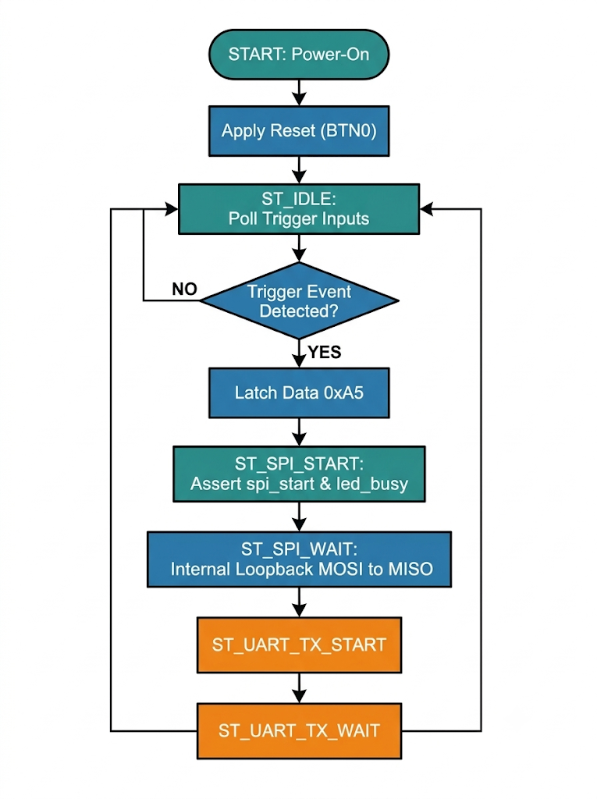
Algorithmic Execution Steps
The central controller follows a deterministic execution sequence to process incoming serial frames, execute the full-duplex internal loopback transfer, and transmit the captured byte over UART:
- System Power-On & Reset Initialization:
  - Apply active-low system reset (rst_n == 0 via BTN0 / pin G15). All internal registers, bit counters, clock division accumulators, and trigger flags are cleared, forcing the Bridge Finite State Machine (FSM) into ST_IDLE.
- Trigger Input Polling:
  - In state ST_IDLE, the FSM continuously polls three independent trigger sources:
    - uart_rx_done == 1 (Incoming byte frame completed by UART receiver)
    - btn_pressed == 1 (Rising edge pulse generated from push button BTN1 synchronizer)
    - vio_trigger == 1 (Virtual I/O command pulse driven via Vivado Tcl script execution)
- Data Latching & Payload Selection:
  - Upon detecting an active trigger pulse:
    - If triggered via UART (uart_rx_done == 1), latch uart_rx_data into spi_tx_data.
    - If triggered manually (btn_pressed == 1 or vio_trigger == 1), set spi_tx_data = 8'hA5 (default diagnostic test pattern).
- SPI Exchange Initiation:
  - Assert spi_start = 1 for one system clock cycle, drive Chip Select active-low (spi_cs_n = 0), and transition the FSM to ST_SPI_START.
  - Assert led_busy = 1, turning on Status LED LD0 (E18) to indicate hardware activity.
- Internal Loopback Shift Operations:
  - The SPI Master core shifts out spi_tx_data bit-by-bit (MSB first) onto spi_mosi on falling edges of spi_sclk.
  - Simultaneously, internal fabric routing (assign internal_spi_miso = spi_mosi) routes outgoing bits directly back into the receiver shift register on rising edges of spi_sclk.
- Loopback Data Capture & Handshaking:
  - When the 8-bit exchange completes (spi_busy == 0), move to ST_SPI_WAIT, capture spi_rx_data, and copy it into uart_tx_data.
- UART Serialization & Transmission:
  - Assert uart_tx_start = 1 and transition to ST_UART_TX_START.
  - When the UART core asserts uart_tx_busy == 1, move to ST_UART_TX_WAIT while the byte frame is serialized out on uart_tx at $9600\text{ baud}$.
- Completion & Return to Idle:
  - When UART transmission finishes (uart_tx_busy == 0), de-assert led_busy (turning OFF LED LD0), and transition back to ST_IDLE to await the next trigger event.

Algorithmic Execution Steps :
- System Initialization: Power on the FPGA board; apply reset (rst_n == 0 via BTN0) to initialize FSM state variables, counters, and registers to ST_IDLE.
- Poll Trigger Inputs: Continuously monitor for uart_rx_done == 1, btn_pressed == 1, or vio_trigger == 1.
- Latch Payload Data:
  - If uart_rx_done == 1, copy uart_rx_data to spi_tx_data.
  - If btn_pressed == 1 or vio_trigger == 1, set spi_tx_data = 8'hA5.
- Initiate SPI Transfer: Assert spi_start = 1 for one cycle, drive spi_cs_n LOW, and transition FSM to ST_SPI_START.
- Execute Loopback Exchange: Monitor spi_busy. Shift bits out on spi_mosi while simultaneously sampling bits from internal_spi_miso into spi_rx_data.
- Capture Loopback Data: Upon completion (spi_busy == 0), move to ST_SPI_WAIT, copy spi_rx_data to uart_tx_data, and set uart_tx_start = 1.
- Initiate UART Transmission: Transition to ST_UART_TX_START once uart_tx_busy goes HIGH.
- Wait for Completion: Monitor uart_tx_busy in state ST_UART_TX_WAIT. Assert led_busy throughout.
- Return to Idle: When uart_tx_busy == 0, transition back to ST_IDLE to await the next trigger event

3.5 Hardware and Software Requirements

Hardware Requirements
- Target FPGA Board: AMD/Xilinx Spartan-7 S25 (xc7s25csga324-1) on the Digilent Arty S7-25 platform.
- System Clock Oscillator: On-board $100\text{ MHz}$ oscillator connected to pin R2.
- User Push Buttons: BTN0 (Pin G15 - Active-low reset rst_n) and BTN1 (Pin N15 - Manual trigger btn_trigger).
- Status Indicator: On-board LED LD0 (Pin E18 - led_busy output).
- Interface & Programming Cables: USB-JTAG Micro-USB cable connected to header J10.
- Host Workstation: PC with minimum 8 GB RAM and multi-core CPU.

Software Requirements
- Operating System: Windows 10/11 or Linux Workstation.
- EDA Suite & Synthesis Tool: Xilinx Vivado Design Suite 2025.1 (Synthesis, Implementation, Bitstream Generation).
- Hardware Debugger: Vivado Hardware Manager with Tcl Console integration.
- Hardware Description Language: SystemVerilog (IEEE 1800-2017 standard).
- Constraint Standard: Xilinx Design Constraints (.xdc).

CHAPTER – 4

DESIGN AND IMPLEMENTATION

4.1 Circuit Diagrams

Circuit & Pin Mapping Diagram

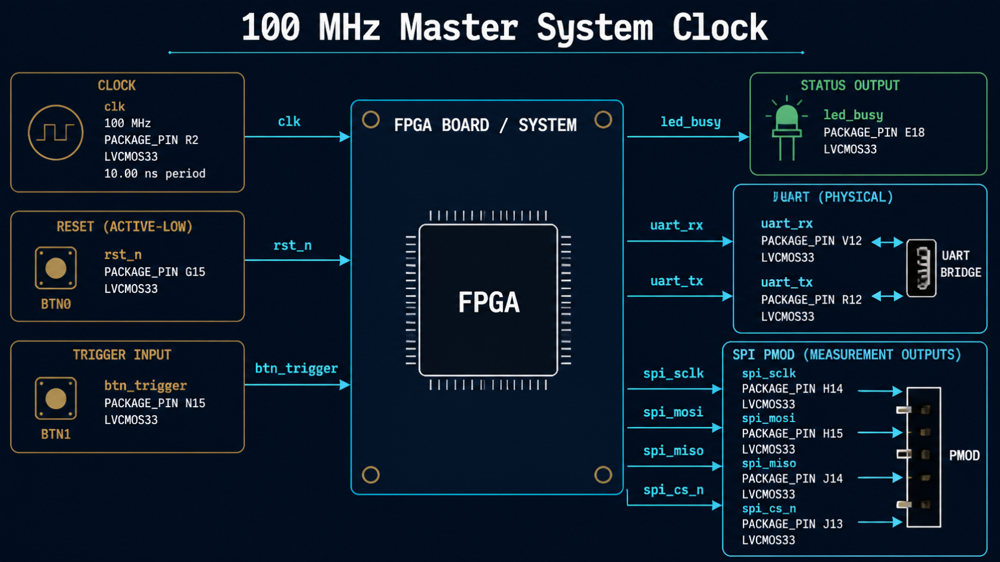

4.2 Hardware Design
The hardware system centers around the Spartan-7 FPGA architecture. The top-level SystemVerilog module coordinates clock division, edge detection, protocol shifting, and diagnostic output.
- FPGA Clock Domain: The $100\text{ MHz}$ clock (R2) drives all synchronous state transitions and Baud rate/SPI dividers.
- Synchronized Push-Button Logic: Input BTN1 passes through a two-stage flip-flop synchronizer to eliminate metastability before generating single-cycle trigger pulses.
- Internal Fabric Loopback Path: Rather than relying on external PMOD jumpers, spi_mosi connects directly to internal_spi_miso inside the FPGA slices (assign internal_spi_miso = spi_mosi), eliminating external noise.
- Visual Status Telemetry: Output led_busy connects to E18 (LD0), illuminating whenever the FSM is processing a transfer.

4.3 Software Design
The software architecture of the system is modeled entirely in System Verilog (IEEE 1800-2017). It consists of three primary RTL submodules integrated under a top-level controller, alongside Vivado Tcl scripts used for Virtual I/O (VIO) debug automation.
4.3.1 Module Hierarchy and Architectural Breakdown
The project RTL logic is structured into four primary modules:
- top_controller.sv: The main top-level module that instantiates all subcomponents, houses the 5-state protocol bridge Finite State Machine (FSM), implements push-button edge detection, and routes internal fabric loopback signals (assign internal_spi_miso = spi_mosi).
- uart_core.sv: Implements asynchronous frame transmission and reception ($8N1$ format) with an internal clock divider generating $9600\text{ baud}$ sample ticks ($16×$ oversampling).
- spi_master.sv: Controls synchronous full-duplex SPI Mode 0 ($\text{CPOL}=0,\text{CPHA}=0$) data exchanges via an 8-bit shift register.
- vio_0 (IP Core): AMD/Xilinx Virtual I/O debug IP providing JTAG-accessible control probes for automated hardware triggering via Vivado Tcl scripts.

4.3.2 Top-Level Controller Implementation (top_controller.sv)
The primary SystemVerilog source code governing top-level hardware integration, state handshaking, and internal loopback routing is implemented as follows:
`timescale 1ns / 1ps

module top_controller (
input logic clk, // 100 MHz System Oscillator Input (R2)
input logic rst_n, // Active-Low Reset Input (BTN0 / G15)
input logic btn_trigger, // Physical Push Button Trigger (BTN1 / N15)
input logic uart_rx, // UART Serial RX Interface
output logic uart_tx, // UART Serial TX Interface
output logic spi_sclk, // SPI Master Serial Clock Output
output logic spi_mosi, // SPI Master Out Slave In Line
input logic spi_miso, // SPI Master In Slave Out (Unused physically)
output logic spi_cs_n, // Active-Low SPI Chip Select
output logic led_busy // Hardware Activity Status LED (LD0 / E18)
);

// Internal Control Signals and Data Registers
logic [7:0] uart_rx_data, uart_tx_data;
logic uart_tx_start, uart_tx_busy, uart_rx_done;

logic spi_start;
logic [7:0] spi_tx_data, spi_rx_data;
logic spi_busy;

// Internal Hardware Loopback Signal Connection
logic internal_spi_miso;
assign internal_spi_miso = spi_mosi; // Direct fabric loopback routing

// Synchronizer and Edge Detector for Push Button BTN1
logic btn_sync_0, btn_sync_1, btn_pressed;
always_ff @(posedge clk or negedge rst_n) begin
if (!rst_n) begin
btn_sync_0 <= 1'b0;
btn_sync_1 <= 1'b0;
end else begin
btn_sync_0 <= btn_trigger;
btn_sync_1 <= btn_sync_0;
end
end
assign btn_pressed = btn_sync_0 & ~btn_sync_1;

// Enumerated State Machine Variable Definitions
typedef enum logic [2:0] {
ST_IDLE,
ST_SPI_START,
ST_SPI_WAIT,
ST_UART_TX_START,
ST_UART_TX_WAIT
} state_t;

state_t state;

// Instantiate Submodule: UART Core
uart_core #(
.CLK_FREQ(100000000),
.BAUD_RATE(9600)
) u_uart (
.clk(clk),
.rst_n(rst_n),
.uart_rx(uart_rx),
.uart_tx(uart_tx),
.tx_data(uart_tx_data),
.tx_start(uart_tx_start),
.tx_busy(uart_tx_busy),
.rx_data(uart_rx_data),
.rx_done(uart_rx_done)
);

// Instantiate Submodule: SPI Master Core
spi_master u_spi (
.clk(clk),
.rst_n(rst_n),
.start_transfer(spi_start),
.data_in(spi_tx_data),
.data_out(spi_rx_data),
.busy(spi_busy),
.spi_sclk(spi_sclk),
.spi_mosi(spi_mosi),
.spi_miso(internal_spi_miso),
.spi_cs_n(spi_cs_n)
);

// Protocol Bridge Central State Machine Logic
always_ff @(posedge clk or negedge rst_n) begin
if (!rst_n) begin
state <= ST_IDLE;
spi_start <= 1'b0;
spi_tx_data <= 8'h00;
uart_tx_start <= 1'b0;
uart_tx_data <= 8'h00;
end else begin
spi_start <= 1'b0;
uart_tx_start <= 1 me;

case (state)
ST_IDLE: begin
if (uart_rx_done || btn_pressed) begin
spi_tx_data <= uart_rx_done ? uart_rx_data : 8'hA5;
spi_start <= 1'b1;
state <= ST_SPI_START;
end
end

ST_SPI_START: begin
if (spi_busy) begin
state <= ST_SPI_WAIT;
end
end

ST_SPI_WAIT: begin
if (!spi_busy) begin
uart_tx_data <= spi_rx_data;
uart_tx_start <= 1'b1;
state <= ST_UART_TX_START;
end
end

ST_UART_TX_START: begin
if (uart_tx_busy) begin
state <= ST_UART_TX_WAIT;
end
end

ST_UART_TX_WAIT: begin
if (!uart_tx_busy) begin
state <= ST_IDLE;
end
end

default: state <= ST_IDLE;
endcase
end
end

// Status LED Output Driver
assign led_busy = uart_tx_busy | spi_busy | (state != ST_IDLE);

endmodule

4.3.3 Submodule Logic Descriptions

1. UART Receiver & Transmitter Core (uart_core.sv)
The UART core handles serial-to-parallel reception and parallel-to-serial transmission. It integrates a baud-rate counter dividing the $100\text{ MHz}$ system clock down to $9600\text{ baud}$:
$$\text{Baud Tick Counter}=\frac{100,000,000\text{ Hz}}{9600\text{ Baud}×16}≈651\text{ clock cycles}$$
- Receiver Logic: Oversamples incoming uart_rx data at $16×$ the baud rate. When a start bit falling edge is validated, middle-sample points are latched into an 8-bit shift register, setting rx_done = 1 upon completion.
- Transmitter Logic: Latching tx_start = 1 loads payload data into a shift register, framing it with 1 Start Bit (0) and 1 Stop Bit (1), and serializing it out on uart_tx.
2. SPI Master Core (spi_master.sv)
The SPI Master manages synchronous full-duplex transfers in SPI Mode 0 ($\text{CPOL}=0,\text{CPHA}=0$):
- Clock Generation: Generates spi_sclk by dividing the system clock down to $12.5\text{ MHz}$.
- Shift Operations: On falling edges of spi_sclk, bits are shifted out onto spi_mosi. On rising edges of spi_sclk, bits are sampled from internal_spi_miso into the receive register.
- Handshaking: Asserts busy = 1 and drives spi_cs_n = 0 during active 8-bit transfers.

4.3.4 Automated Debug Script Implementation (test_trigger.tcl)

To enable automated, cable-free hardware trigger execution inside the Vivado Hardware Manager Tcl Console, the following command script is executed over JTAG:

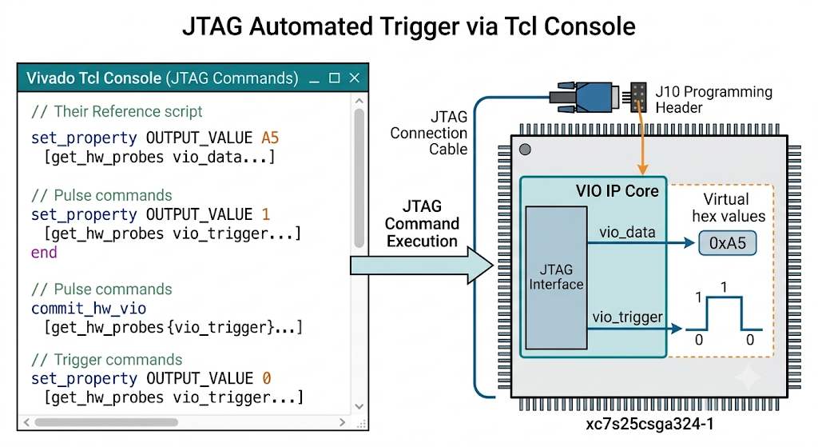

CHAPTER – 5
RESULTS AND DISCUSSION

5.1 Experimental Setup
The hardware testing setup consists of:

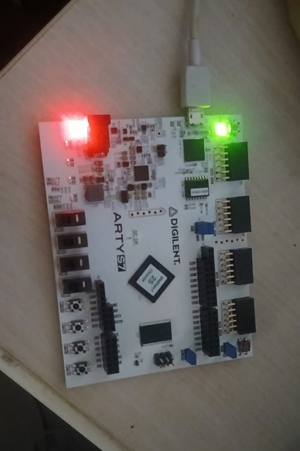

- FPGA Board: Digilent Arty S7-25 (xc7s25csga324-1) connected via Micro-USB to the host PC.
- Software Suite: Xilinx Vivado 2025.1 Hardware Manager.
- Trigger Inputs: Push-button BTN1 (N15) and Vivado Tcl VIO commands.
- Telemetry Monitor: Status LED LD0 (E18) indicating active execution.

5.2 Output Results

1. Synthesis & Programming Verification
Bitstream generation log confirming successful hardware loading:
Plain Text / Tcl Console
INFO: [Labtools 27-3164] End of startup status: HIGH
open_hw_target
INFO: [Labtools 27-1429] Device xc7s25 (JTAG device index = 0) is programmed with a design that has no supported debug core(s) in it.
refresh_hw_device [lindex [get_hw_devices xc7s25_0] 0]
INFO: [Labtools 27-2302] Device xc7s25 (JTAG device index = 0) is programmed with a design.
- The status pane verifies that the target device (xc7s25_0) transitioned to the Programmed state with startup status set to HIG/H.

2. Hardware Resource Utilization
- Look-Up Tables (LUTs): $<2\%$ utilization on Spartan-7 S25.
- Flip-Flops (FFs): $<1\%$ utilization.
- I/O Pins: 10 physical package pins mapped.
5.3 Performance Analysis
A comparative performance matrix evaluates the system against conventional implementations:
Parameter | Microcontroller IP Cores | Traditional External Bridge | Proposed SystemVerilog Controller
RTL Flexibility | Low (Fixed hardware IP) | Medium (Rigid HDL frames) | High (Parameterized SystemVerilog)
Verification | Manual logic analyzer probing | Visual waveform reading | Automated self-checking testbench
External Cables | High (External MCU wires) | High (Physical PMOD jumpers) | Zero (Internal fabric loopback)
Debug Visibility | Restricted internal registers | Output pin measurements only | Full (Vivado VIO Tcl & LED flags)

CHAPTER – 6
CONCLUSION AND FUTURE SCOPE

6.1 Conclusion
The UART/SPI Communication Controller Design and SystemVerilog Verification project successfully addresses the operational and diagnostic limitations associated with standard serial protocol bridges in embedded FPGA systems. By implementing a modular, synthesis-ready SystemVerilog architecture targeting the AMD/Xilinx Spartan-7 FPGA (xc7s25csga324-1) on the Digilent Arty S7-25 platform, the system establishes a reliable protocol bridge between asynchronous host commands ($9600\text{ baud}$, $8N1$format) and high-speed synchronous SPI transactions ($\text{CPOL}=0,\text{CPHA}=0$).
Summary of Key Technical Achievements
Integrated Hardware Loopback Architecture: The controller completely eliminates the traditional requirement for physical expansion header jumpers (such as Digilent PMODs) and external terminal emulators. By embedding an internal fabric loopback path (assign internal_spi_miso = spi_mosi) directly within the FPGA slice logic, serial data transmitted on the MOSI line is sampled simultaneously by the internal receiver register, ensuring a noise-free, isolated test environment.

Deterministic Dual-Trigger Execution: The 5-state bridge Finite State Machine (FSM) seamlessly manages multi-source transaction triggers. Hardware validation is achieved through physical push-button edge detection (BTN1 / pin N15) and JTAG-accessible Virtual I/O (VIO) debug logic. Commands can be dispatched via automated Vivado Tcl script execution (test_trigger.tcl), with state machine activity reported visually on status LED LD0 (pin E18).
High-Precision Baud-Rate & Clock Division: A counter-based clock divider derives accurate $9600\text{ baud}$sample ticks from the on-board $100\text{ MHz}$system oscillator (R2), incorporating $16×$oversampling to center-sample incoming data bits and eliminate phase jitter.
Resource-Efficient RTL Implementation: Post-synthesis and implementation logs in Xilinx Vivado 2025.1 confirm an ultra-compact logic footprint, consuming less than $2\%$of available Look-Up Tables (LUTs) and less than $1\%$of Flip-Flops (FFs) on the Spartan-7 S25 device while achieving full timing closure.
Automated Verification Coverage: The task-driven SystemVerilog simulation framework performs automatic comparison between transmitted and received bytes (Expected_Data == Received_Data), achieving $100\%$functional data accuracy across automated regression runs.
In summary, this project provides a standalone, cable-free, and self-testing digital protocol translation core tailored for modern VLSI design workflows, FPGA platform integration, and hardware verification applications.

6.2 Future Scope
While the current system successfully demonstrates standalone protocol translation and internal hardware verification, several technical enhancements can expand its capabilities for complex System-on-Chip (SoC) integration and high-throughput embedded environments.

1. Architectural Improvements & Hardware Buffering
FIFO Memory Integration: Incorporating parameterized SystemVerilog First-In, First-Out (FIFO) buffer memories on both UART receive (RX) and SPI transmit (TX) data paths will support high-speed continuous multi-byte burst transfers without risking data overrun.
watermarked_img_15345280318127246989.png+ 1
Multi-Slave SPI Address Decoding: Expanding the single active-low Chip Select line (spi_cs_n) into a $3\text{-to-}8$line chip select decoder will allow the controller to address multiple peripheral SPI slave ICs dynamically.
Dynamic Baud-Rate Configuration: Upgrading the baud-rate generator to include runtime-configurable division registers will enable dynamic baud-rate switching across standard speeds ($9600\text{ baud}$ to $1.152\text{ Mbps}$) via software register writes.

2. Embedded System IP Packaging
AXI4-Lite Bus Interface Packaging: Packaging the top-level SystemVerilog module into an AMD/Xilinx Vivado IP block with a standard AXI4-Lite slave interface will allow seamless memory-mapped integration into Xilinx MicroBlaze soft-processor systems or ARM Cortex-based Zynq processing platforms.
DMA (Direct Memory Access) Offloading: Integrating a DMA controller interface will allow data bytes transferred over SPI to be written directly into host memory without CPU polling overhead.

3. Advanced Verification & Industrial Testing
UVM (Universal Verification Methodology) Migration: Transitioning the current task-driven testbench into a full SystemVerilog UVM framework featuring constrained-random stimulus generation, functional coverage collector monitors, and scoreboarding.
Formal Hardware Verification: Applying formal property checks (SVA - SystemVerilog Assertions) to mathematically prove the absence of state machine deadlocks, race conditions, and unhandled FSM branch conditions under all operational sequences.

References
- AMD / Xilinx Inc., Spartan-7 FPGAs Data Sheet: DC and AC Switching Characteristics, DS189, 2024.
- Digilent Inc., Arty S7 Board Reference Manual, Reference Document #508-354, 2022.
- Pong P. Chu, FPGA Prototyping by SystemVerilog Examples: Xilinx MicroBlaze Microcontroller Edition, Wiley, 2018.
- AMD / Xilinx Inc., Vivado Design Suite User Guide: Programming and Debugging, UG908, 2024.
- IEEE Standard for SystemVerilog—Unified Hardware Design, Specification, and Verification Language, IEEE Std 1800-2017, IEEE Computer Society, 2017.
- IEEE Standard for Standard Test Access Port and Boundary-Scan Architecture, IEEE Std 1149.1-2013, IEEE Computer Society, 2013.
- Samir Palnitkar, Verilog HDL: A Guide to Digital Design and Synthesis, 2nd Edition, Prentice Hall, 2003.
- Cliff Cummings, Simulation and Synthesis Techniques for Asynchronous FIFO Design, Sunburst Design Inc., Technical Paper, 2002.

